Title of your presentation for ISEM2021

FirstName FamilyName* and FirstName FamilyName**

*Affiliation, Address, Country
**Affiliation, Address, Country
E-mail : E-mail@corresponding.author

Abstract
The objectives of the 7th International Symposium on Energetic Materials and their Applications (ISEM2021) include both fundamental researches and industrial applications relevant to energetic materials, and are to obtain an overview of the most recent international research efforts and to provide opportunities for scientists and engineers to establish avenues for cooperation and collaboration.
All prospective authors for Oral Presentation and Poster Presentation should submit A4 one page abstract with one or two optional figures or tables as per the online procedure on the website by 21 May, 2021.
http://www.jes.or.jp/isem/2021/submissions/abstract.html.
For the topic of the prospective presentation, please choose from the following list of topics:
http://www.jes.or.jp/isem/2021/overview/topics.html.
The accepted abstracts will be included in the ISEM2021 abstract book.
As for the full paper, please submit on online submission site of the Journal of "Science and Technology of Energetic Materials". For the format of the full paper, please see "Notes for Contributors" of the Journal of "Science and Technology of Energetic Materials". The due date to submit the full paper is 19 November, 2021.
http://www.jes.or.jp/mag_eng/index.html
Selected papers featuring the presentations during the ISEM2021 will be eligible for publication on the Journal of "Science and Technology of Energetic Materials".

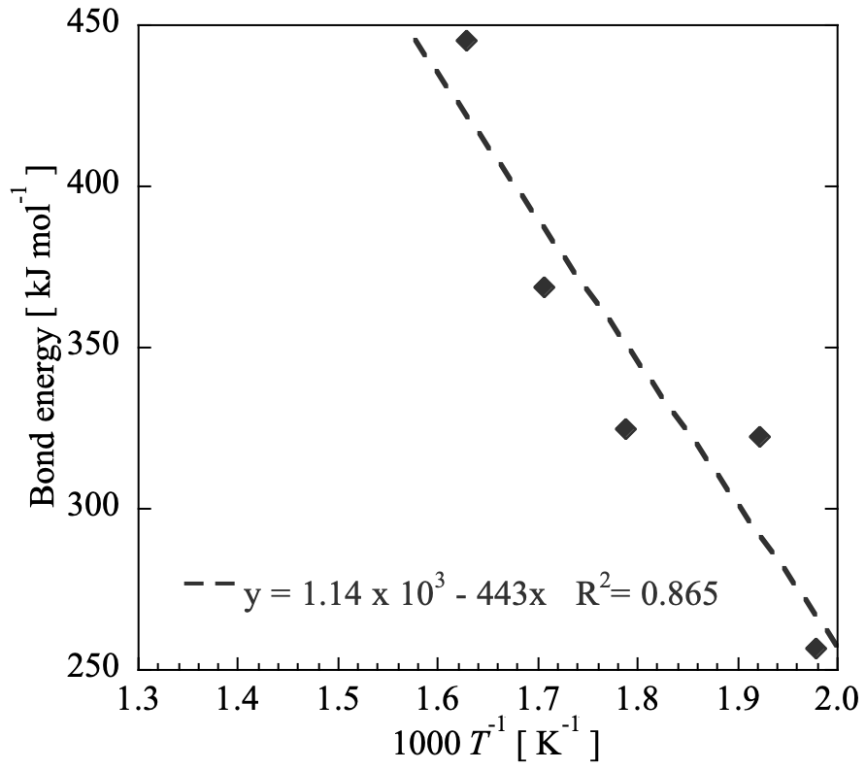
Figure 1 Relationship between bond energy and onset temperatures^{1), 2)}.

References
1) A. Bbbb, C. Dddd, and E. Ffff, Sci. Technol. Energ. Mater., 81, 1, 1-6 (2020).
2) G. Hhhh and I. Jjjj, Sci. Technol. Energ. Mater., 81, 3, 51-56 (2020).

